

Web Technologies (CSC 3215)

Lecture Note 5

Week 5

Supta Richard Philip

Richard@aiub.edu

Faculty of Science and Technology

Department of Computer Science

Contents

What is a Cookie? 2

Example of cookie 2

Create Cookies in PHP 2

Delete a Cookie 3

PHP Session 3

Example of session 3

Exercise 4

References 6

# What is a Cookie?

A computer “cookie” is more formally known as an HTTP cookie, a web cookie, an Internet cookie, or a browser cookie.  When you visit a website, the website sends the cookie to your computer. Your computer stores it in a file located inside your web browser.

A website might also use cookies to keep a record of your most recent visit or to record your login information. Many people find this useful so that they can store passwords on commonly used sites, or simply so they know what they have visited or downloaded in the past.

Session cookies are used only when a person is actively navigating a website; once you leave the site, the session cookie disappears. Tracking cookies may be used to create long-term records of multiple visits to the same site.

## Example of cookie

A cookie is often used to identify a user. A cookie is a small file that the server embeds on the user's computer. Each time the same computer requests a page with a browser, it will send the cookie too. With PHP, you can both create and retrieve cookie values.

## Create Cookies in PHP

A cookie is created with the setcookie() function.

setcookie(name, value, expire, path, domain, secure, httponly);

<?php

$cookie_name = "user";

$cookie_value = "John Doe";

setcookie($cookie_name, $cookie_value, time() + (86400 * 30), "/"); // 86400 = 1 day

?>

<html>

<body>

<?php

if(!isset($_COOKIE[$cookie_name])) {

echo "Cookie named '" . $cookie_name . "' is not set!";

} else {

echo "Cookie '" . $cookie_name . "' is set!<br>";

echo "Value is: " . $_COOKIE[$cookie_name];

}

?>

</body>

</html>

## Delete a Cookie

To delete a cookie, use the setcookie() function with an expiration date in the past:

<?php

// set the expiration date to one hour ago

setcookie("user", "", time() - 3600);

?>

<html>

<body>

<?php

echo "Cookie 'user' is deleted.";

?>

</body>

</html>

# PHP Session

A session is a way to store information (in variables) to be used across multiple pages.

Unlike a cookie, the information is not stored on the users computer.

## Example of session

A session is started with the session_start() function.

Session variables are set with the PHP global variable: $_SESSION.

<?php

session_start();

?>

<!DOCTYPE html>

<html>

<body>

<?php

// Echo session variables that were set on previous page

echo "Favorite color is " . $_SESSION["favcolor"] . ".<br>";

echo "Favorite animal is " . $_SESSION["favanimal"] . ".";

?>

</body>

</html>

Another way to show all the session variable values for a user session is to run the following code:

<?php

session_start();

?>

<!DOCTYPE html>

<html>

<body>

<?php

print_r($_SESSION);

?>

</body>

</html>

To remove all global session variables and destroy the session, use session_unset() and session_destroy():

<?php

session_start();

?>

<!DOCTYPE html>

<html>

<body>

<?php

// remove all session variables

session_unset();

// destroy the session

session_destroy();

?>

</body>

</html>

## Exercise

1. Design a multi steps registration form and process data using session.

Step 1:

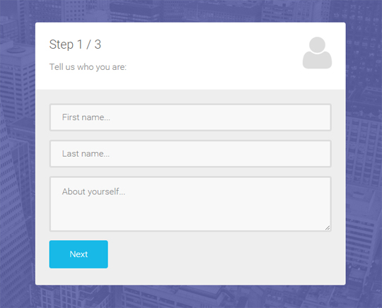

Step 2:

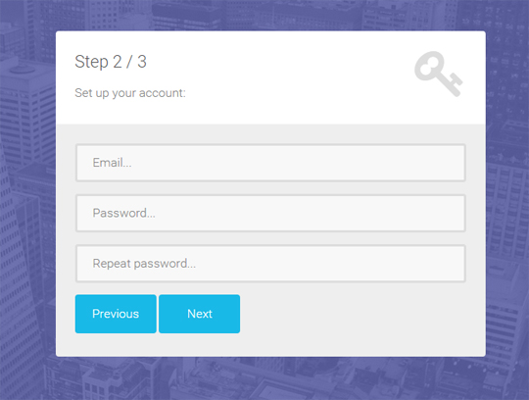

Step 3:

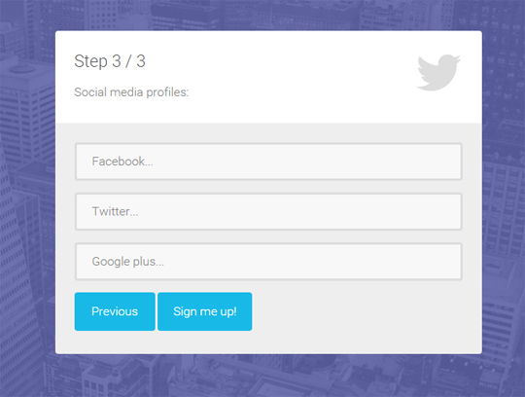

# References

[1]. <https://www.w3schools.com/php/php_cookies.asp>